DOCUMENTATION
DDL Commands:
1. Table Creation (CREATE):
Database ‘employee’ is created: -
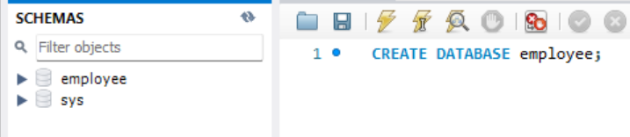
Table ‘Departments’ is created: -
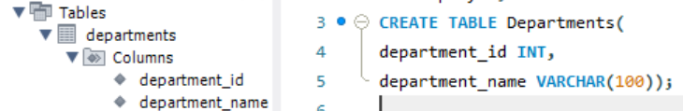
Table 'Location’ is created: -
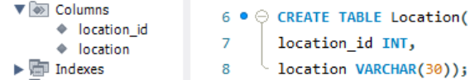
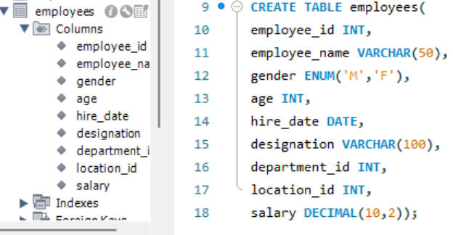
Table ‘employees’ is created: -

2.Table Alteration (ALTER): -

⦿ Add a new column named "email" to the Employees table to store
employee email addresses.
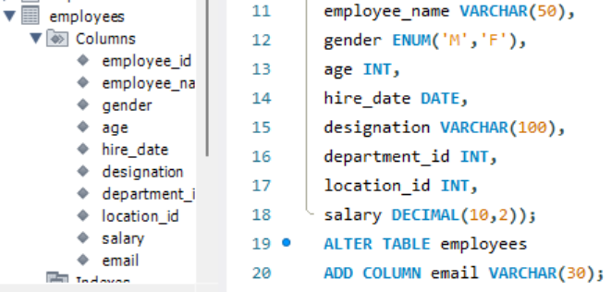
⦿ Modify the data type of the "designation" column in the Employees
table to support a wider range of values.
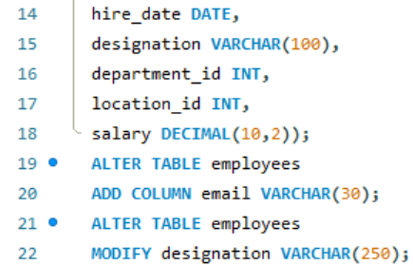

⦿ Drop the “age” column from the Employees table.
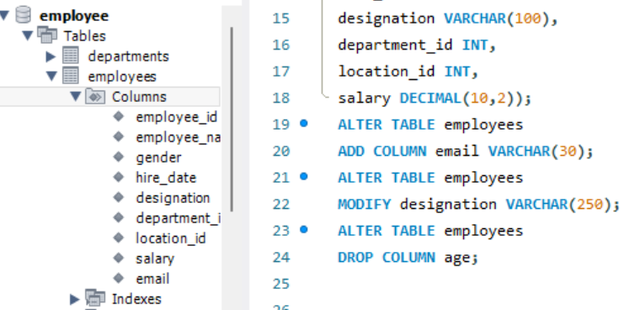
Now the column ‘age’ is absent from the schema.

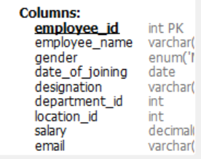
⦿ Rename the “hire_date” column to “date_of_joining”.
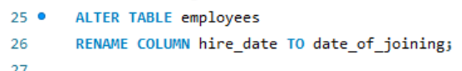

3. Table Renaming (RENAME): -
⦿ Rename the "Departments" table to "Departments_Info".
⦿ Rename the "Location" table to "Locations".
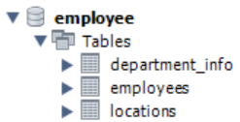
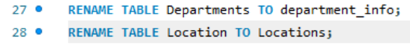

4. Table Truncation (TRUNCATE): - Write an SQL statement to truncate the
Employees table.
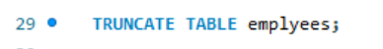
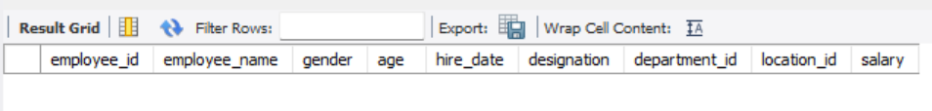
5. Database & Table Dropping (DROP): Write the SQL statements to drop the
Employees table and then the “employee” database.
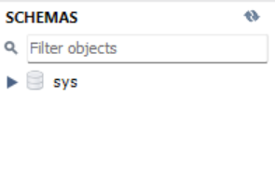
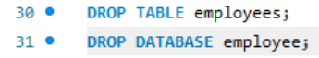
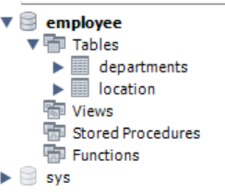

Constraints :
- Database Recreation:
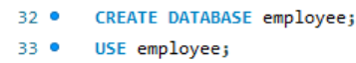
2. Departments Table:

⦿ Ensure that the "department_id" uniquely identifies each department.
⦿ Set up constraints on the "department_name" to avoid duplicate and null
entries.
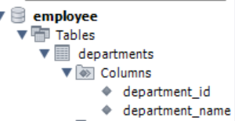
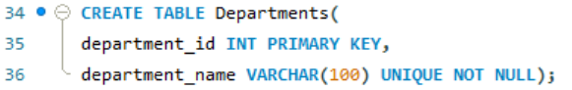
3. Location Table:

⦿ Establish a mechanism to automatically generate unique identifiers for
each location, ensuring that they are incremented sequentially.
⦿ Implement constraints to prevent the insertion of null and duplicate
locations.
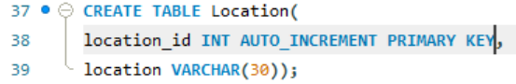

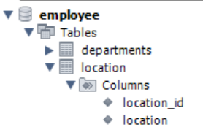
4. Employees Table:
⦿ Guarantee that each employee has a distinct identifier.
⦿ Create a restriction to ensure that the employee's name is always
provided.
⦿ Limit the acceptable values for the "gender" field to only 'M' or 'F'.
⦿ Enforce a condition to ensure that the employee's age is 18 or above.
⦿ Automatically assign the current date to the "hire_date" field if not
specified.
⦿ Establish links between the "department_id" and "location_id" fields in
the "employees" table and their respective tables.
